|  |  |
| --- | --- |
| **TEAM ID:** | NM2023TMID05840 |
| **PROJECT NAME:** | To create brand promo video |
| **DATE:** | 2 November 2023 |

**Code layout readability and reusability**

**Our page layout**

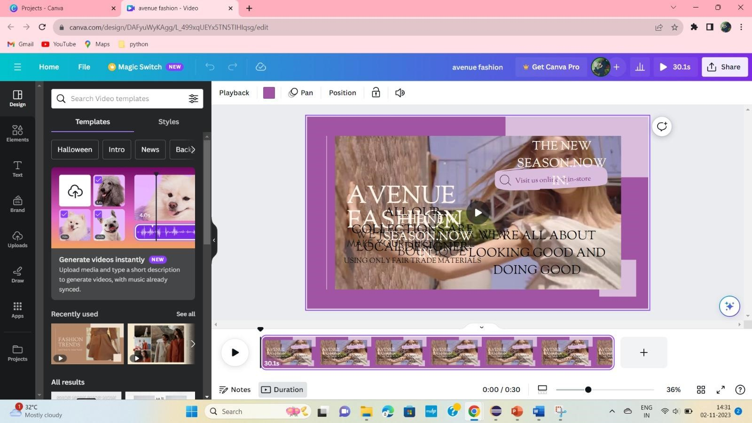

* **Choose a Template**: Canva offers various video templates. Select one that suits your brand's style and the message you want to convey.
* **Script and Storyboard**: Plan your video content in advance. Create a script and a storyboard to determine what elements will be included in each scene.
* **Design Elements**:
  1. **Images and Videos**: Use high-quality images and videos that resonate with your brand's message. Ensure they are clear, relevant, and support your narrative.
  2. **Text Overlays**: Add text to your video to convey your message. Make sure the text is concise, legible, and consistent with your brand's fonts and colors.
  3. **Transitions**: Use smooth transitions between scenes to create a seamless viewing experience. Canva provides transition effects that you can apply to your video.
  4. **Animations**: Animate text and graphics to make your video engaging. Be careful not to overdo it, as it can affect readability.
* **Audio**:
  1. **Background Music**: Choose background music that complements the mood of your video and your brand's identity. Ensure it doesn't overpower the voiceover or main message.
  2. **Voiceover**: If using a voiceover, ensure that the narrator's voice is clear, and the pace matches the video's flow.
* **Layout and Readability**:
  1. **Text Placement**: Position text where it doesn't obscure important visual elements. Use legible fonts and font sizes.
  2. **Contrast**: Ensure there is enough contrast between text and background to make it readable.
  3. **Consistency**: Keep your video's design elements consistent with your brand's visual identity. Use the same fonts, colors, and logo throughout.
* **Reusability**:
  1. **Canva Libraries**: Save and organize your brand assets in Canva's libraries. This makes it easier to reuse your brand elements in future projects.
  2. **Templates**: Save your video project as a template if you plan to create similar videos in the future. This saves you time on design.
* **Preview and Edit**: After creating your video, preview it to ensure all elements are working together effectively. Make adjustments as needed.
* **Export**: When you're satisfied with your video, export it in your desired format and resolution. Canva provides options for different video formats.
* **Sharing**: Share your video on social media, your website, or through other marketing channels to reach your target audience.